Phase 1: Problem Statement
I’ve observed that our organization is currently experiencing difficulties in attracting and retaining top-performing employees. This situation is negatively impacting productivity, team cohesion, and the retention of valuable institutional knowledge. Given the competitive nature of today’s job market, especially within our industry, standing out as an employer of choice is crucial. Attrition, which is our target variable, appears to be driven primarily by low wages, inadequate benefits, and a lack of clear career advancement opportunities. Traditional retention tactics no longer work, so we must now invest in employee development, fair compensation, and transparent career pathways to improve retention.
From my analysis, I found that employees earning $2,911 or less per month — the bottom 25% of income — account for 25.1% of our workforce. Within this group, the attrition rate is nearly 29.3%, which is significantly higher than our overall attrition rate of 16.1%. This strongly suggests a link between low compensation and high turnover. Additionally, about 10% of our employees are over the age of 50, and this demographic likely values healthcare, retirement planning, and flexible work arrangements. Tailored strategies are needed to retain this valuable part of our workforce.
Attrition has major financial implications. Replacing an employee can cost up to 200% of their salary, not to mention the indirect costs of morale loss and project delays. As industries nationwide grapple with labor shortages—especially in rural areas like ours—retaining talent becomes even more critical. Today’s workforce demands flexibility, mental wellness, and purpose in their careers. Organizations that proactively meet these needs will retain talent and remain competitive.
Phase 2: Data Preprocessing and Exploration
My goal was to prepare the data for analysis and uncover trends that could help explain attrition. I began by cleaning the data, checking for missing values, outliers, and inconsistencies. No missing values were found. Columns with only one unique value were flagged for removal, and several outliers were identified for review. As part of my exploratory data analysis (EDA), I focused on numeric features with the highest variation, such as MonthlyIncome, MonthlyRate, Age, and YearsAtCompany. These variables are likely to have the greatest influence on attrition and will be prioritized for modeling.
I visualized distributions and looked for trends or patterns among employee attributes, particularly in relation to attrition. I normalized numerical variables and used encoding techniques for categorical values to prepare the dataset for modeling. These foundational steps ensured that the dataset was clean, usable, and optimized for deeper predictive analysis.

Phase 3: Machine Learning Models
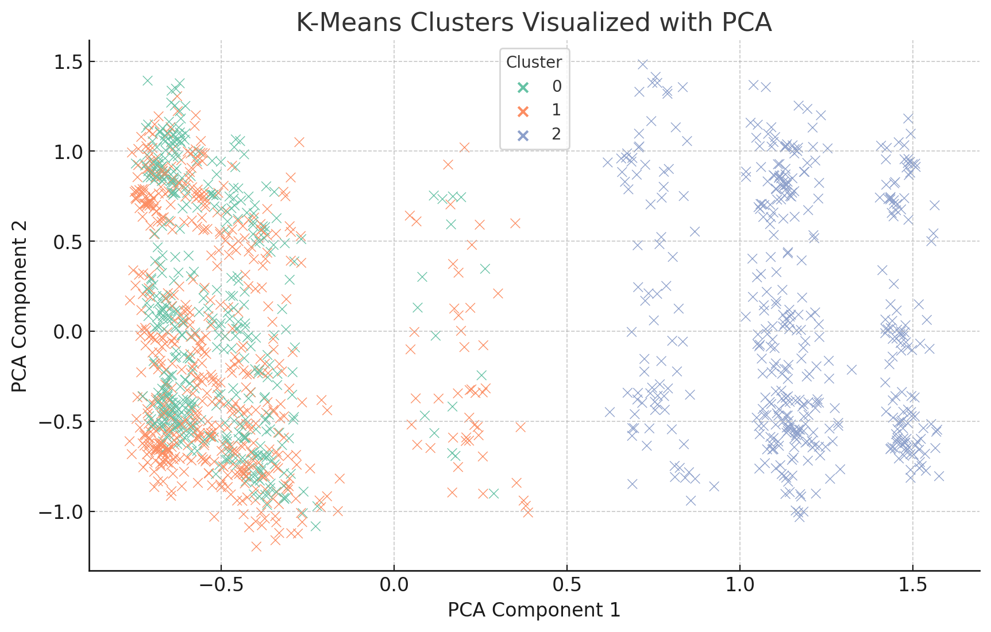
For clustering, I first removed non-informative features like EmployeeCount and Over18. Then I encoded categorical variables and normalized all numerical fields. The KMeans algorithm grouped employees into three clusters: Cluster 0 represented stable employees with moderate satisfaction, Cluster 1 included employees with slightly lower engagement, and Cluster 2 consisted mainly of high-attrition Sales roles with low satisfaction. Cluster 2 should be our top priority for intervention and retention strategies.
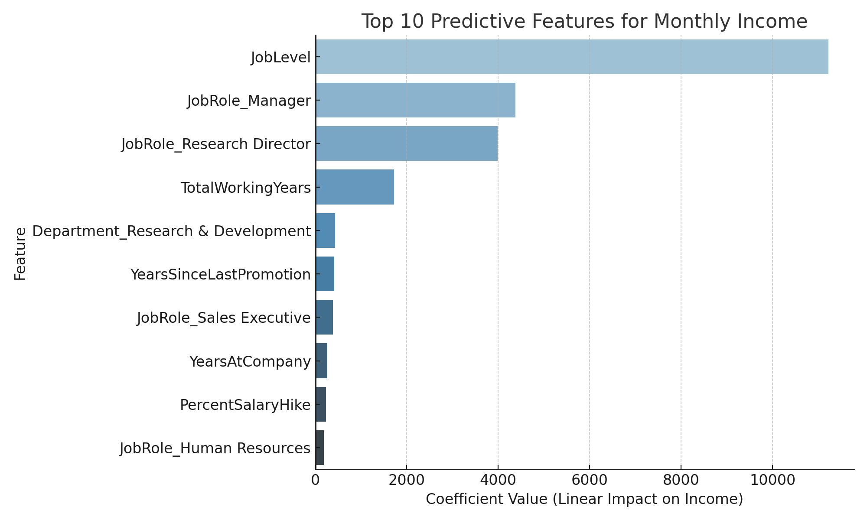
For regression, I predicted MonthlyIncome using multiple linear regression. I removed irrelevant fields, encoded variables, normalized values, and split the data for training and testing. The most predictive features included JobLevel, JobRole, and TotalWorkingYears. The regression model performed well and can be used for compensation planning and pay equity evaluations.

Phase 4: Model Evaluation

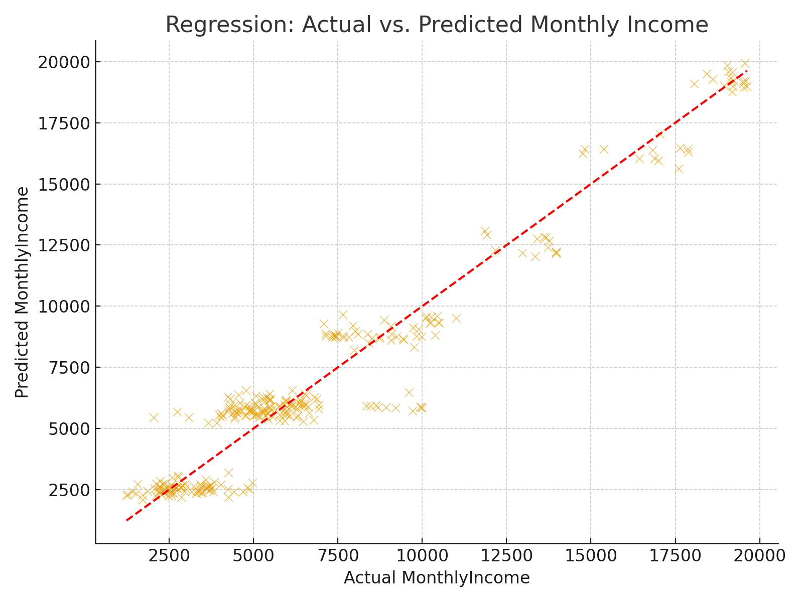
The regression model predicting MonthlyIncome achieved strong results with a Mean Absolute Error of 893.05, Root Mean Squared Error of 1168.16, and R² score of 0.94—indicating excellent predictive performance.
Logistic regression was used to predict attrition. Performance was evaluated using accuracy, precision, recall, F1-score, and the confusion matrix. The model provided valuable insights into which employees are at higher risk of leaving.
Each model was evaluated with metrics appropriate to its purpose—regression metrics for income prediction and classification metrics for attrition. Both models showed reliable performance and support data-driven decision-making.

Phase 6: Presentation
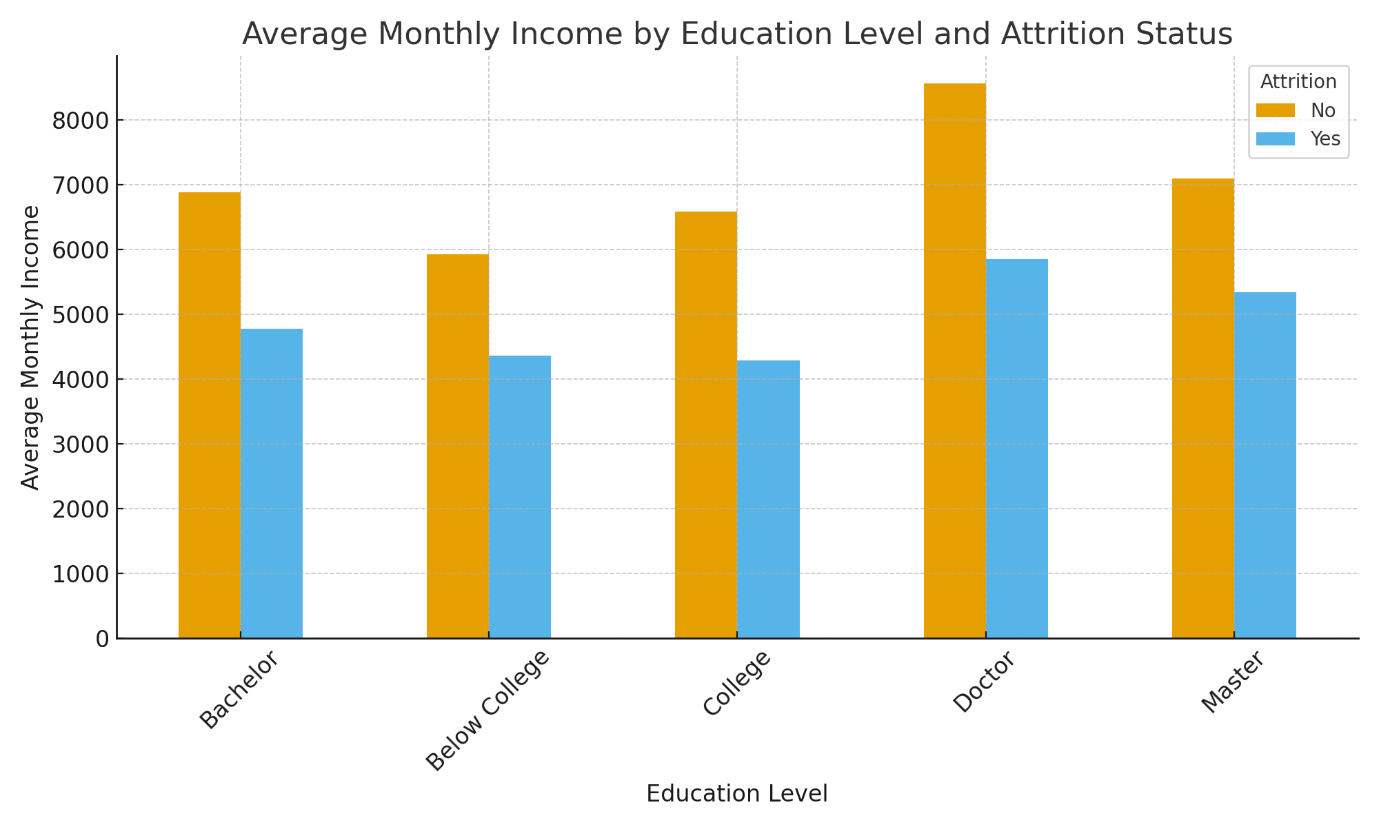
To reduce attrition, I recommend reassessing our compensation structure, especially for lower-paid roles. Establishing career development programs and improving internal mobility can increase employee satisfaction and engagement. Retention efforts for older employees should focus on job security, benefits, and flexible scheduling. Predictive models should be used regularly to identify at-risk individuals early. Finally, improving data collection on promotions, engagement, and manager feedback will enhance future models and provide more accurate insights.

